Supplementary Material
TSMSPL: a three-classification neonatal pain assessment model based on tripartite subsets and self-learning
Rui Miao Qing-Hua Huang Fangxin Luoye Ming-Yue Hu1 Zi-Han Don Ren-Li Deng
*Correspondence: Ren-li Deng
E-mail Address: dengrenli.research@outlook.com
1. Neonatal pain dataset creation process
1.1. Participants
The data collection was carried out in the Affiliated Hospital of Zunyi Medical University. For this study, 214 neonates admitted to the neonatal intensive care unit (NICU) between January and August 2023 were selected as the training model dataset (Set A), and 188 neonates admitted between September and December 2023 were selected as the validation model dataset (Set B). A total of 402 subjects (206 males and 196 females; age 0-28 days) were studied. Collect general information about the neonate, including sex, gestational age, birth weight and type of pain-causing operation. Neonates who underwent pain-causing manipulation due to therapeutic needs were included in this study, while those with occluded faces and bodies were excluded, as well as those who were excessively ill, comatose, receiving sedation and analgesia. Before recording each subject, the guardian of the subject was required to sign a written informed consent. The study was approved by the Biomedical Research Ethics Committee of the Affiliated Hospital of Zunyi Medical University (Approval No.: KLLY-2022-159) and registration was completed in the China Clinical Trial Registry (Registration No.: ChiCTR2300074085).
1.2 Data acquisition
To eliminate possible study errors in dietary requirements and excretory actions, we performed breastfeeding and nappy changes 30 minutes before the neonate underwent sensitive therapeutic measures such as peripheral blood sampling, arterial puncture or intubation. At the same time, the environmental parameters of the incubator were also appropriately adjusted to ensure that the neonate was comfortable, stable and ready in a nude, flat position. During the procedure, overhead photography with a GoPro camera to document systemic pain responses in neonates. This filming process was initiated 2 minutes before the start of the medical procedure and ended 5 minutes after the completion of the procedure. It is important to note that this study was only videotaped when medically prescribed by a physician based on therapeutic needs, and no additional invasive steps were ever added.
1.3 Human proofreading scoring method
Once the video was completed, two trained senior caregivers accurately assessed the neonatal pain level using the multi-validated and widely used Neonatal Infant Pain Scale (NIPS), and the video was reviewed and the analysis was performed. The NIPS tool brings together seven key pain-related indices, ranging from facial musculoskeletal changes (0 to 1), crying level (0 to 2), respiratory style (0 to 1), upper limb posture (0 to 1), and respiration pattern (0 to 1). (0 to 1), cry level (0 to 2), breathing pattern (0 to 1), upper limb posture (0 to 1), lower limb posture (0 to 1), and arousal level (0 to 1), with the overall score varying between zero and seven.
Based on these metrics, pain levels were subdivided into different grades: mild pain (0 to 2 points), moderate pain (3 to 4 points), and severe pain (5 to 7 points). The two nurses performing the assessment relied on NIPS to meticulously classify the level of discomfort exhibited by each neonate in the video, and these classification results not only provided an important basis for subsequent pain management, but also provided the factual labels that underpinned the training of the classifiers to ensure that we were able to more accurately identify and assess neonatal pain responses.
1.4 Scoring consistency test
The use of a multi-rater strategy when conducting a research subject examination is essential to ensure the accuracy of the assessment results. However, this strategy is accompanied by certain challenges, namely the need to assess the consistency of ratings between different raters as well as the same rater at different points in time. To this end, we introduced the concept of consistency testing, which aims to quantitatively assess the degree of similarity of results obtained for the same research subject across multiple tests or across different raters.
Next, we used the Intraclass Correlation Coefficient (ICC) as an assessment tool to quantify the between-group consistency between two raters as well as the within-group consistency of each rater at different time points (e.g., one week apart). The level of the ICC value directly reflects the degree of consistency of the scoring results. Typically, we consider inter-rater or the same rater at different time points to have very high consistency when the ICC value is greater than 0.75; an ICC value between 0.4 and 0.75 indicates good consistency; and an ICC value below 0.4 indicates poor consistency. This quantitative assessment method provides clear guidance to ensure the reliability and accuracy of the assessment results.
1.5 Data preprocessing
During the filming process, although we try our best to avoid interference from external factors, due to the nature of manual filming, unforeseen circumstances such as lens reflections, or the obscuring of the neonatal face or body regions may occasionally occur. To ensure the accuracy of the data and the reliability of the study, the original video was first edited initially to eliminate clips that did not show the full body of the neonate.
Next, a second edit is performed, this time with the goal of pinpointing the 5-minute clips of neonates with the most significant pain responses from the initially screened video clips. This step is crucial for subsequent analyses because it highlights the true response of the neonate in the pain state.
Finally, we will further filter the most representative 10-second clips among these 5-minute clips, which will be used as key sample data for training the classification model. By doing three clips in this way, we are able to ensure that the video data used is both comprehensive and accurate, and that it truly reflects the pain responses of neonates.
For ease of management and identification, the pre-processed videos will be named with a combination of the video memory card designation combined with the shooting serial number, ensuring that each video clip has its own unique identification.

2. Evaluation indicators
2.1 Accuracy
Accuracy refers to the ratio of the number of correctly predicted samples to the total number of predicted samples. This is one of the most common classification indicators. However, this indicator cannot fully evaluate the model when the data is not balanced. Therefore, we also use Precision, Sensitivity, F1-score, Specificity and AUROC as comparison indicators.
2.2 Precision
Precision refers to the ratio of the number of correctly predicted positive samples to the number of all predicted positive samples.

2.4 F1-score
F1-score is equivalent to the harmonic average of precision and sensitivity, and the result will refer to both indicators at the same time.

2.6 AUROC
AUROC stands for "Area under the ROC (Receiver Operating Characteristic) curve." That is, AUROC measures the entire two-dimensional area underneath the entire ROC curve from (0,0) to (1,1).

3. Comparison model
3.1 Swin (Swin Transformer: Hierarchical Vision Transformer using Shifted Windows):
Swin Transformer is a general-purpose vision Transformer model proposed by Microsoft Research Asia that is capable of constructing hierarchical feature representations and has a computational complexity that is linear in the size of the input image. The model improves efficiency and allows cross-window connectivity by using the self-attention mechanism of a shift window.Swin Transformer excels on a wide range of visual tasks, including image classification, target detection, and semantic segmentation, outperforming the best previous models.

VVIT (ViViT: A Video Vision Transformer):
VVIT is a pure Transformer model proposed for video classification tasks, aiming to improve the efficiency of the Transformer architecture in video understanding tasks. The model reduces computational complexity by decomposing the spatial and temporal attention mechanisms in the Transformer encoder. VVIT demonstrates how to efficiently regularise the model on a small dataset with pre-trained image models. VVIT achieves state-of-the-art results on multiple video classification datasets.

TSN (Temporal Segment Networks):
TSN is a deep learning method for behaviour recognition in videos. TSN improves classification performance by segmenting a video into multiple time segments, modelling these time segments independently, and then aggregating their predictions. TSN has achieved significant performance gains on behaviour recognition tasks, and has become a classic model in the field.

Slowfast:
SlowFast Networks is a deep learning model for video understanding tasks that combines slow and fast paths to capture spatio-temporal information in videos. The model is designed to process video data and is capable of capturing fast motion and slow changes.
I3D (Inflated 3D ConvNets)
I3D is a model that extends a 2D convolutional neural network to 3D space for video understanding tasks.I3D has achieved significant performance on action recognition and other video analysis tasks.

Tripartite
An artificial three-subset sample classification optimisation model based on the Swin Transformer model was performed. The model is based on a variant of Swin Transformer, optimised or trained specifically for three different subsets of data.

Swin-SPL (Video Swim Transform- Self-stepping learning)
Self-stepping learning optimisation was performed based on the Swin Transformer model.’ SPL’ stands for Self-stepping learning training strategy. Self-stepping learning is an adaptive learning rate adjustment strategy for improving the model training process.

TSMSPL (Three-class model based on Tripartite and self-paced learning optimization)
An artificial tri-subset sample classification and self-stepping learning optimisation integrated model based on Swin Transformer model. TSMSPL model construction is mainly divided into three modules, including tri-subset partitioning module, optimisation module based on self-stepping learning for dual model training and fusion prediction module. This is done by finding the output layer from the Video Swin Transformer model, counting the tensor of the penultimate hidden layer and saving it. triple subset partitioning module Here, we propose a triple subset partitioning algorithm based on deep learning hidden layers and K-means clustering. In order to better optimal train the separated noise samples, we propose to use a two-model training algorithm for optimisation. Finally, after completing the training of the $σ_1$ and $σ_2$ models, we construct a third independent model σ_3 ($X$,$ϑ$) for fusion prediction.

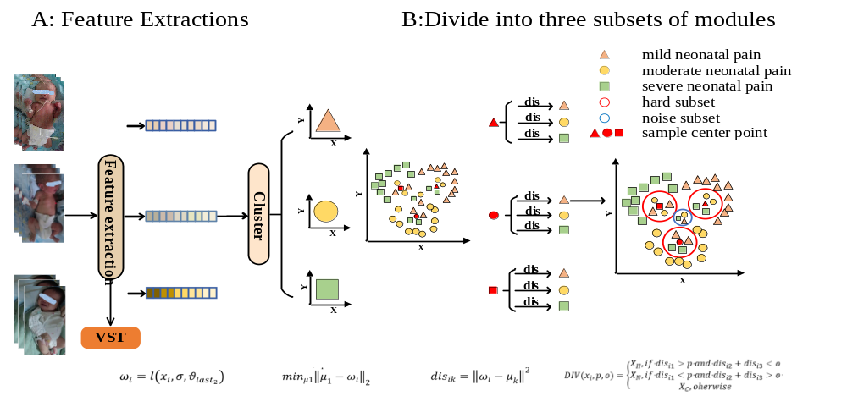
Supplementary Figure S1_The structure of Triplet-set Partitioning Module A: Flow of the feature extraction module, B: Flow of three subsets module based on clustering

Supplementary Figure S2_Experimental results for subset A of the dataset CGNT A: PR for severe neonatal pain in each model, B: AUC for severe neonatal pain in each model

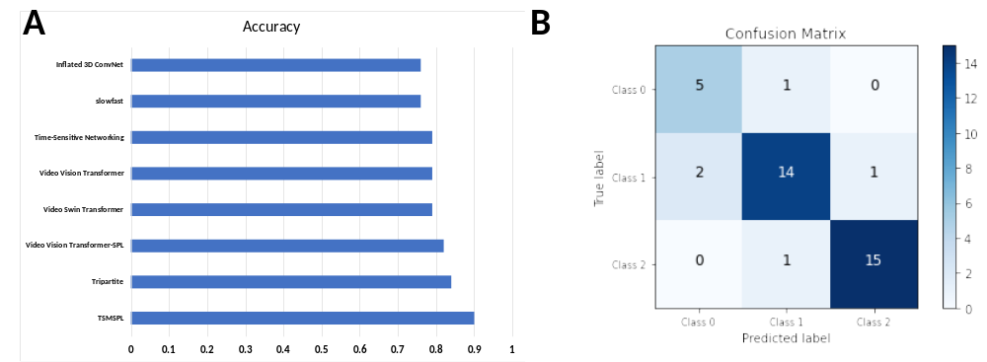
Supplementary Figure S3_Experimental results for subset B of the dataset CGNT A: Accuracy of each model, B: Confusion matrix for the TSMSPL model

Supplementary Figure S4_Experimental results for subset B of the dataset CGNT A: PR for mild neonatal pain in each model, B: AUC for mild neonatal pain in each model, C: PR for moderate neonatal pain in each model, D: AUC for moderate neonatal pain in each model, E: PR for severe neonatal pain in each model, F: AUC for severe neonatal pain in each model

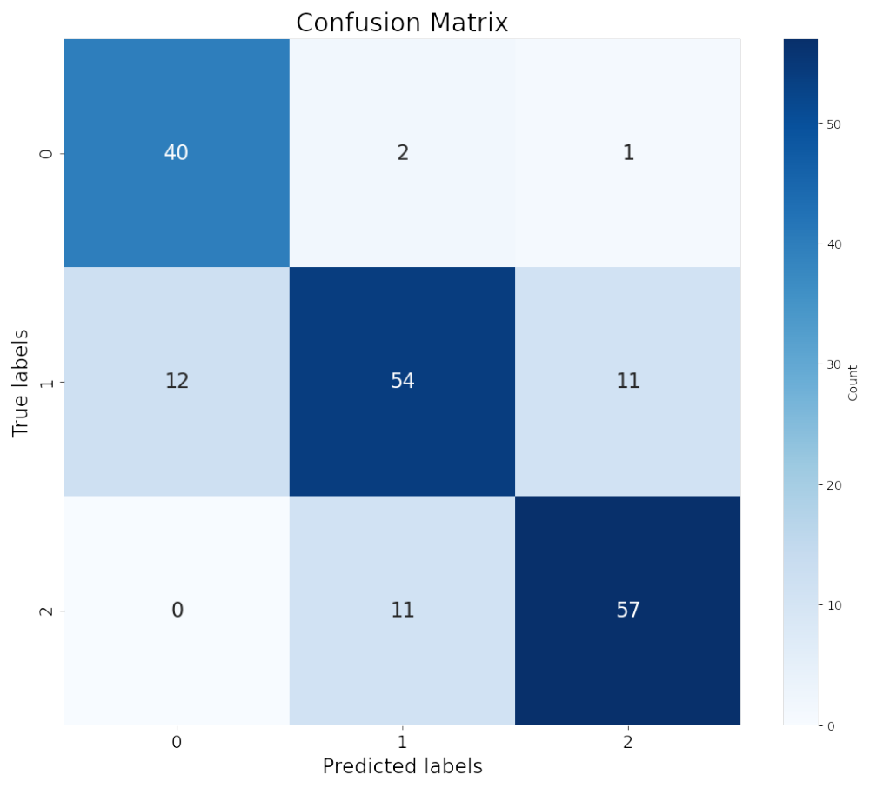
Supplementary Figure S5_ Confusion matrix for the TSMSPL model

Supplementary Figure S6_Experimental results for Independent Verification Experiment A: PR for mild neonatal pain in TSMSPL model, B: AUC for mild neonatal pain in TSMSPL model, C: PR for moderate neonatal pain in TSMSPL model, D: AUC for moderate neonatal pain in TSMSPL model, E: PR for severe neonatal pain in TSMSPL model, F: AUC for severe neonatal pain in TSMSPL model

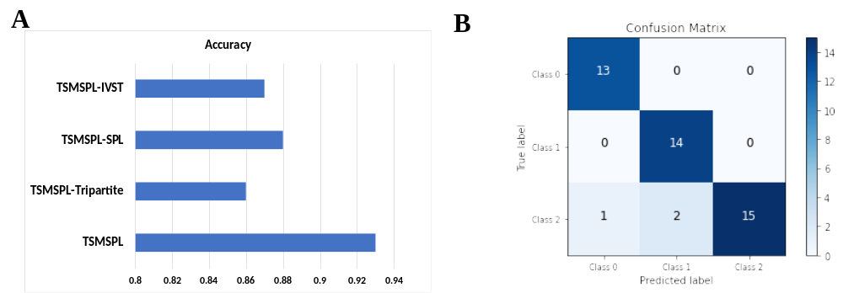
Supplementary Figure S7_Experimental results for ablation experiment A: Accuracy of each model, B: Confusion matrix for the TSMSPL model
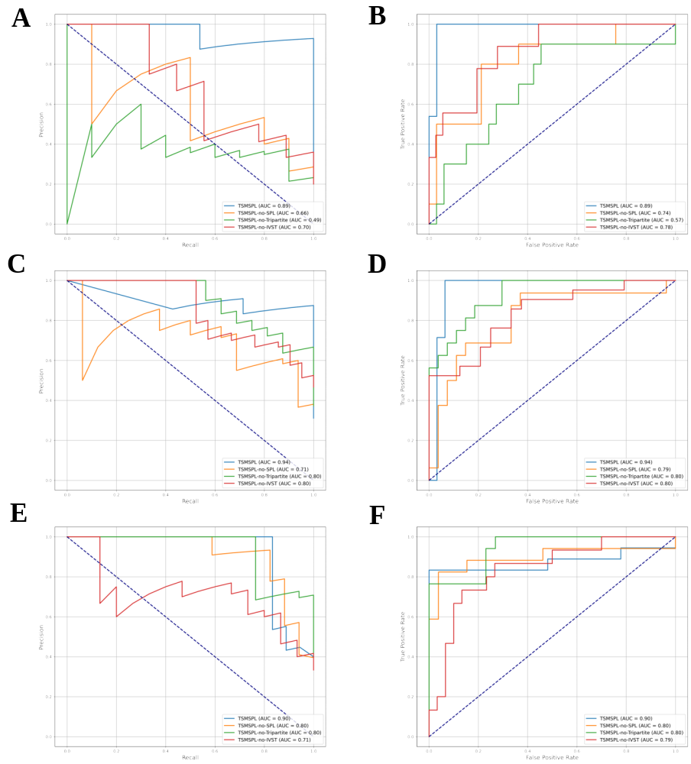
Supplementary Figure S8_Experimental results for ablation experiment A: PR for mild neonatal pain in each model, B: AUC for mild neonatal pain in each model, C: PR for moderate neonatal pain in each model, D: AUC for moderate neonatal pain in each model, E: PR for severe neonatal pain in each model, F: AUC for severe neonatal pain in each model

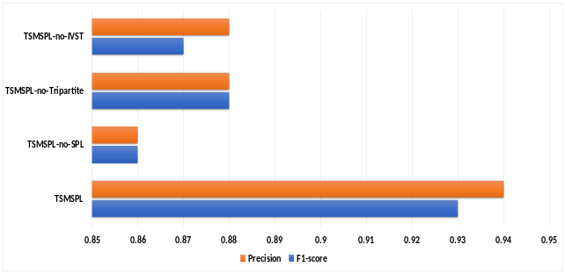
Supplementary Figure S9_ The Result of F1-Score and Precision for Each Model in the Ablation Experiment.

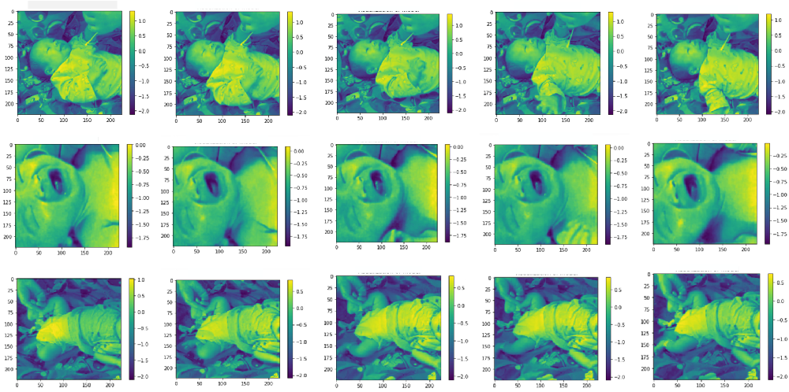
Supplementary Figure S9_Visualization of the TSMSPL model

